

**Trimester: I/II/III Subject:** Basic Mechanical Engineering

**Name**: Krishnaraj Thadesar **Division:** 9

**Roll No.:** 109054 **Batch:** I3

**Experiment No.:** 4

**Name of the Experiment:** Demonstration of Robot-Assisted Welding Process

**Performed on:** 23th September 2021

**Submitted on:** 17th October 2021

*Aim*:

To study the working principle and construction of a slider crank mechanism and to understand working of slider crank mechanism and its inversions.

*Theory:*

Welding is a fabrication process whereby two or more parts are fused together by means of heat and pressure. A strong joint is formed as the part cools. It is generally used on metals and thermoplastics.  
The parts that are joined are known as parent metals.

The base of the parent metal is melted and a filler material is added to help form the joint. A shielding gas is also required to protect the weld area from atmospheric gases. Different energy sources like gas flame, electric arc, laser, electron beam, friction, ultrasound, etc. are used for welding.

*Different types of welding joints are as show in the figure below*

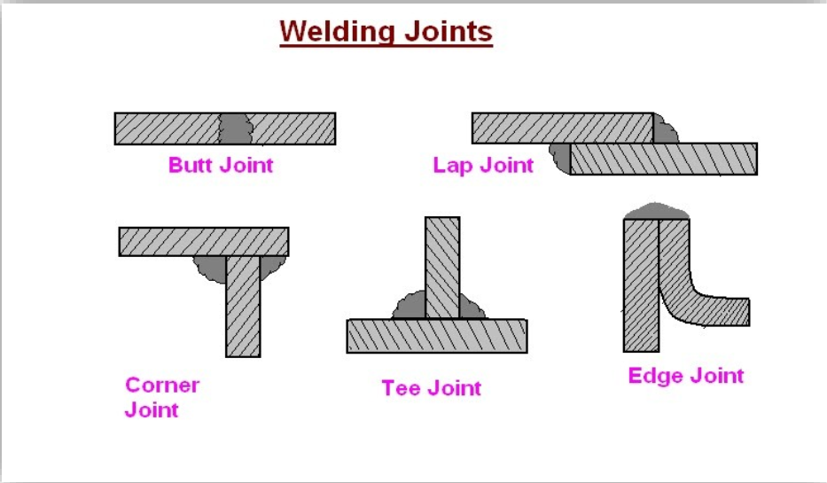

*Need of Robotic Welding:*

Welding is a hazardous process and precautions are required to avoid burns, electric shocks, vision damage, inhalation of poisonous gases and fumes and exposure to radiations. Hence it is desirable to automate the process to require minimal human intervention**.**

*What is Robotic Welding:*Robotic welding is the complete automation of welding process by use of  
mechanized programmable tools. It can perform the welding and also handle the part by itself. This system has filled the gap due to shortage of labour and has improved the accuracy and the productivity. It has a wide range of application in automobile, manufacturing, fabrication, etc.

*Components of Robotic Welding:*The robotic welding system consists of a wide range of components working together to weld pieces. Some components may differ according to the type of welding  
operation. The components of robotic welding machine are labelled in the diagram as follows:

1. *Welding Power Source (A):*It provides the power to the system for working of all components. Its size and capacity vary according to the requirement.
2. *Welding Robot (J):*The robot is the main component that performs the welds. It has an arm that can move in three dimensions for rectilinear types and through more planes in articulating versions. Its selection depends upon its reach, weight – carrying capacity and speed of operation. It is equipped with various mechanical systems, electronic hardware, cables and sensors.
3. *Robot Controller (B) and Interface (C):*The controller is the brain of the system. It has a software program that controls the Robot. It processes the data and gives instructions like parts movement, robot tooling, gripping, etc. The interface allows the user to set and monitor parameters that affect the weld.
4. *Wire Feeder(E):*It supplies the wire to the torch for welding process. Its supply rate depends upon the speed  
   of operation.
5. *Torch(K):* It uses the power flowing in the electrode to heat up and join the materials together. Shielding apparatus and cooling unit (D) is also included in it.
6. *Work Area:*The parts are placed and held here for the robot to weld.
7. *Safety Features:* Robotic welding machine has safety features like fencing, access door, shields, alarms, interlocks, etc. to prevent any harm to operators and workers.
8. *Wire Cleaner:*The cleaner is used to remove spatter from the torch between work cycles prolonging  
   equipment life span.

*Advantages of Robotic Welding over Manual Welding:*

1. Increased efficiency due to longer working hours and high speed
2. Better accuracy due to no human errors
3. Less waste due to precision
4. Enhanced Safety due to no direct human contact and safety features.
5. Once installed, robotic welding is cost effective due to less man power requirement and  
   more efficiency.

*Disadvantages of Robot Welding over Manual Welding*

* 1. Very high investment cost for setting up the machinery
  2. Less flexibility due to fixed programs
  3. Not feasible for small projects and applications due to more cost and time to set up and  
     program

*Future of Robotic Welding*

Since the market of manufacturing is continuously growing the demand for robotic welding is also increasing. There is immense scope for development in this field. Artificial intelligence and sensing  
may be embedded so that the robot would determine the parameters for welding. Collaborative  
robots may also be possible that work side by side with people to accomplish the task. But it may  
lead to decline in jobs for manual welders. Also, the investment cost may lower due to development  
in new technology making it more widely used.

*Conclusion:*

Robotics is playing a very important in improving our standard of living. It is becoming crucial in  
the manufacturing sector also to meet the new standards of accuracy, quality and speed.

A substantial opportunity in technology exists to relive people from monotonous, repetitive work. Welding is a basic process with a widespread application. But manual Welding is a hazardous for the workers and also requires special skills. Hence, robotic welding is more sought out for nowadays though it cannot fully replace manual welding*. It is transforming the industry towards a better future yet a lot more has to be explored in this field to make it feasible for all applications.*